

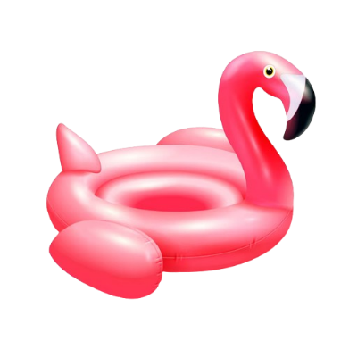

Party Invitation
YOU’RE INVITED TO CELEBRATE WITH US!
POOL PARTY
SATURDAY, 16 MAY

- Street Address: 742 Pixel Parkway, Suite 90.
- Number: +1(555) 012-9876
- Instructions: Follow the balloons to the backyard.

- Please Bring: Your swimsuit and a towel!
- RSVP TO: Vaishnavi, by May 16th!

